EXERCISE 8
- How many unique salary packages does our company, Bignet, offer? List them is descending order.
SELECT DISTINCT salary
FROM employee_data
ORDER BY salary DESC;
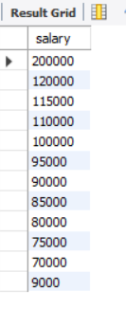
- How many distinct first names do we have in our database?
SELECT COUNT(DISTINCT f_name)
FROM employee_data;
